PRESS RELEASE
25 November 2019
For immediate release
The EU-funded Project Helps SMEs to Integrate Industry 4.0 Technologies in Manufacturing!
AUTOWARE is a research and development project that helps manufacturing SMEs to integrate new digital technologies in their production processes. The project is funded by the biggest EU Research and Innovation programme Horizon 2020. Over the past three years, 14 industrial and academic partners were working together in a cross-border European collaboration. Their goal was to develop technologies that could transform industrial production by making different Industry 4.0 solutions, such as Robotics and Automation, Cyber-Physical Systems and Internet of Things easier to implement in SMEs.

Nowadays small and medium-sized manufacturing companies need to adapt quickly to rapidly changing market demands. The main goal of AUTOWARE is to help those companies to implement Industry 4.0 by creating an open ecosystem that allows SMEs to access new digital technologies and exploit them in their factories.

To achieve this goal, a well-balanced consortium was formed, which includes partners with high expertise in different areas: SQS (Spain), Innovalia (Spain), IK4-Tekniker (Spain), CNR (Italy), Fraunhofer (Germany), Blue Ocean Robotics (Denmark), SmartFactory-KL (Germany), Imec (Belgium), TTTech (Austria), Robovision (Belgium), Jozef Stefan Institute (Slovenia), SMC (Germany), Miguel Hernández University (Spain) and Stora Enso (Belgium).
The AUTOWARE consortium is a mixture of universities, R&D centres, and SMEs, where every partner was developing technologies to bring to market. SMEs can now get a full overview of the project outcomes that can take the production to the next level. All the technologies, developed within the project, make robots and machines work smarter together with people.
During the three years of the project lifetime, the consortium introduced technologies that can be used in manufacturing, industrial automation and production facilities. AUTOWARE Industry 4.0 solutions are both hardware and software technologies within Robotics and Automation, Cyber-Physical Systems and Internet of Things. The integration of such digital technologies into manufacturing processes can help SMEs to stay more efficient in an increasingly competitive environment.

The developed technologies are already demonstrated and validated in a number of use cases and manufacturing settings. SMEs that are interested in acquiring the latest Industry 4.0 technologies are welcomed to contact the AUTOWARE team to get a free consultation on how to integrate these solutions into the production line.
The AUTOWARE Technology Catalogue that provides an overview of all the developed technologies is available in PDF format and can be downloaded here: http://bit.ly/2BZbL3n
For further information please visit our website http://autoware-eu.org/
or contact Mathias Haim Raben at mhr@autoware-eu.dk
You can follow us on Twitter @Autoware_eu and LinkedIn.
This project has received funding from the European Union’s Horizon 2020 research and innovation programme under grant agreement nº 723909
Attached images with captions:

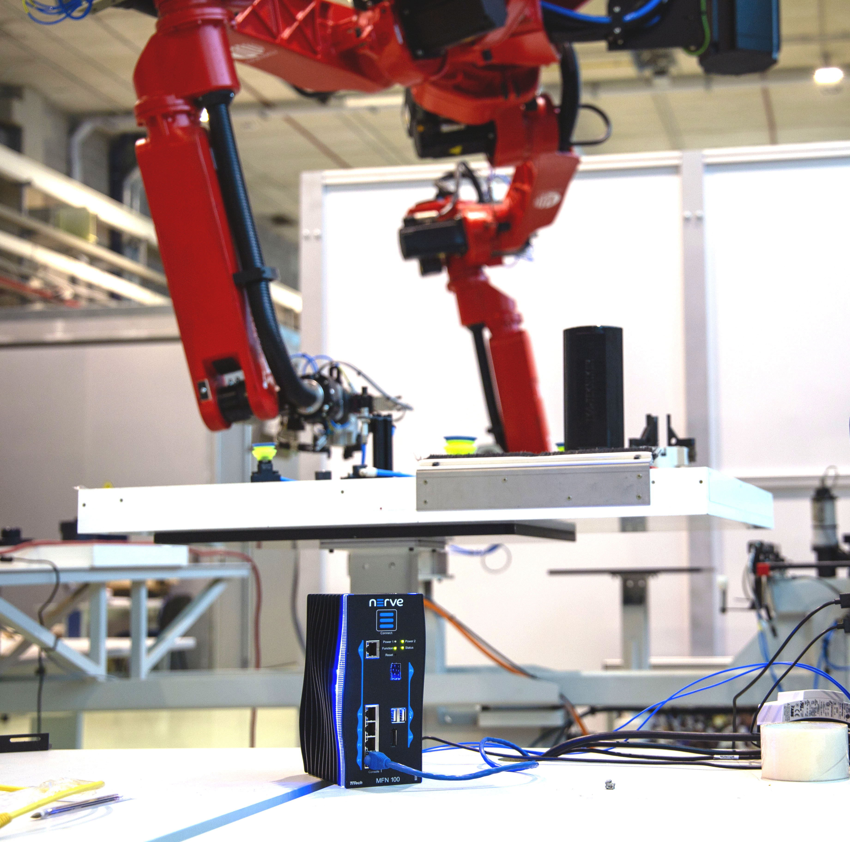
Image 1
The Fog Computing solution is one of the technologies developed within the AUTOWARE project. It can collect, store and analyze machine data as well as run multiple functions on one device.
Image 2
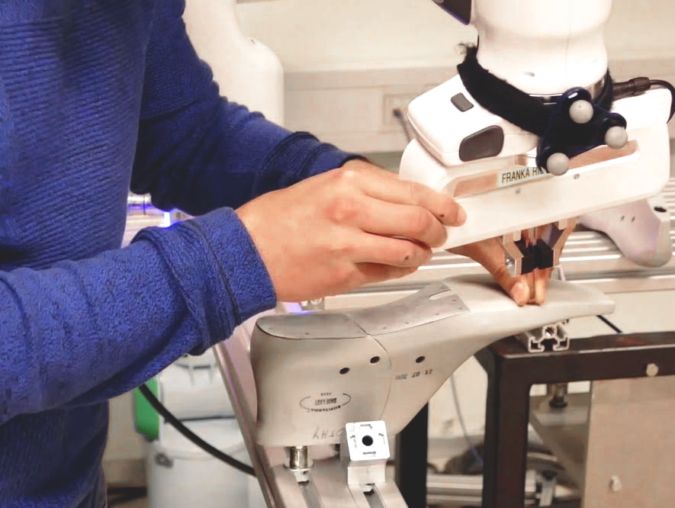
Programming by kinesthetic teaching allows to specify and edit complex robot trajectories in a natural, user-friendly way. Using this technology does not require any special knowledge of robotics.

